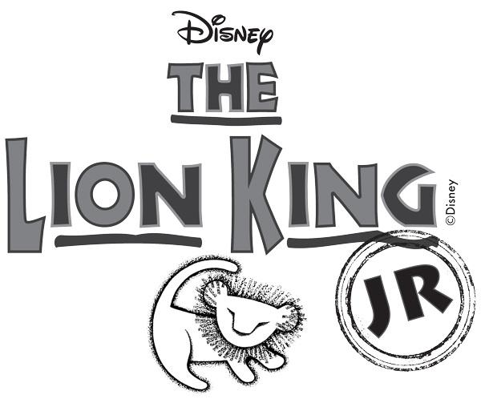
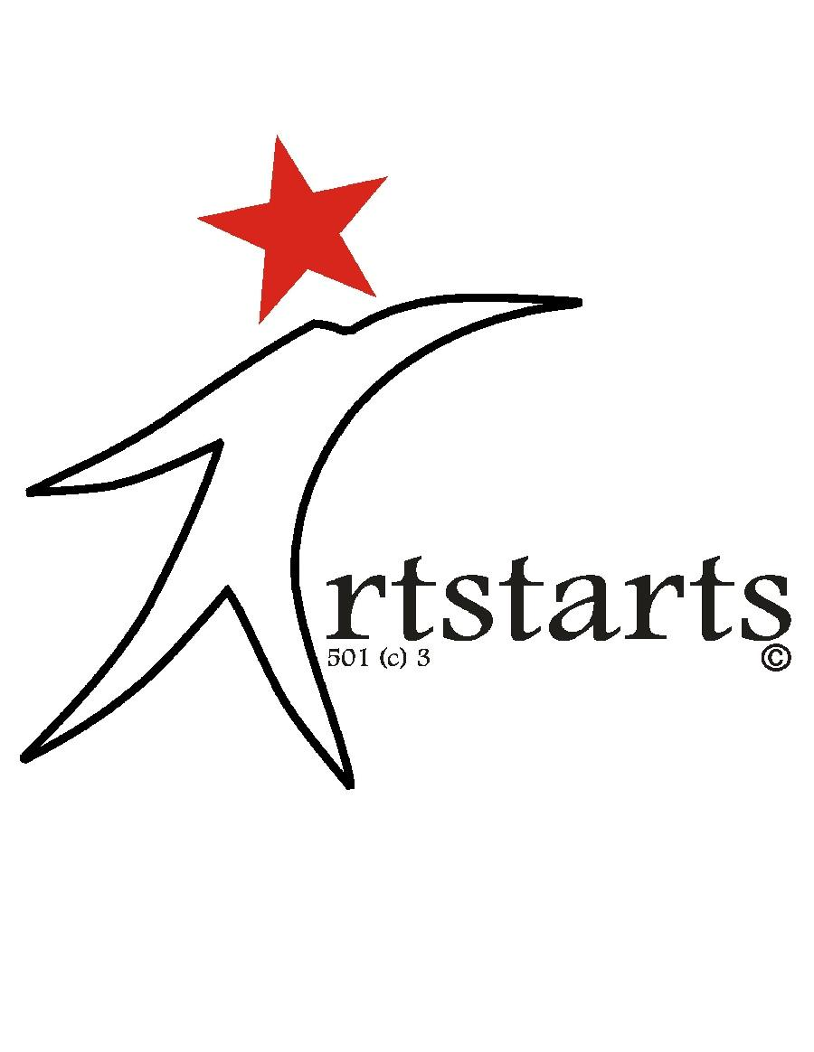

REGISTRATION

 |  | and HEALTH INFORMATION FORMS
Name: |  |  |  | Age: |  |  | Male or Female (circle one)
What grade in school? |  |  | Height:

Where do you attend school? (Include name of School and Town)

Home Address:

Street Town, State ZIP CODE (Please include)

Cast Member’s Email Address (please print clearly):

Cast Member’s Parent’s Email Address (please print clearly):

Telephone Numbers (Include home and cell)

Cast Member’s Telephone Number

Cast Member’s Parents’ Telephone Numbers

. . . . . . . . . . . . . . . . . . . . . . . . . . . . . . . . . . . . . . . . . . . . . . . . . . . . . . . . . . . . . . . . . . . . . . . . . . . . . . .

Cast Member’s T shirt size: (circle one): |  |  | T-SHIRT $15
Child: | 6/8 10/12 14/16
Adult: | Small MediumLargeX Large | XX Large | XXX Large
- - - - - - - - - - - - - - - - - - - - - - - - - - - - - - - - - - - - - - - - - - - - - - - - - - - - - - - - - - - - - - - - - - -

Do we have your permission to post your name and photograph to our website and in social

media? Yes or No ? (Circle answer)

. . . . . . . . . . . . . . . . . . . . . . . . . . . . . . . . . . . . . . . . . . . . . . . . . . . . . . . . . . . . . . . . . . . . . . . . . . . . . . .

COSTUMES $60

All cast members will be required to pay an up-front cost of $60 for their costumes. We will have a sewing team working on costumes each week with fabrics and designs selected by

Artstarts. We invite you to help us create your child’s costume during our sewing sessions. IF YOU HAVE FRIENDS THAT SEW, PLEASE RECRUIT THEM. These costumes are not available for purchase elsewhere. Main characters and featured dancers will have additional costume costs, to be determined, and the up front costume charge that those cast members pay will be applied toward their costume costs.

I have read this and understand that I am responsible for purchasing my child’s costumes. Initial here: _________

I need help toward this cost, and am willing to help Artstarts in other ways to contribute toward the cost of the production. I will discuss other options with Artstarts’ staff. ________

Registration Fee ($45) for Lion King. Jr.

or Commitment to Sell Tickets

There is a $45 registration fee for cast members in the show. The fee helps offset Artstarts’ cost for professional music theater instruction for your child for many weeks. For families with numerous children in the show, the maximum registration fee is $100 + $15 for each child’s t-shirt. The $45 of the registration fee will be waived for each cast member who sells 25 tickets to the show. Registration fees for families with multiple children in the show would be waived for families that sell 50 tickets to the show. (Again, we request that you pay for your t-shirts and costumes.)

You have two options for addressing the Registration Fee. Circle the Option you Choose:

- Pay the $45 fee up front.

- Purchase 25 tickets at the Cast Ticket Event which is scheduled for October 3, beginning at 9 a.m., at the Marion Cultural and Civic Center. Practice will also be at the MCCC that day. Tickets are $15. All seats are reserved. T-shirts will be distributed that day too. You should take orders and collect money for tickets between now and the Cast Ticket Event. Bring the ticket orders and money collected to the Cast Ticket Event. All checks should be made payable to Artstarts Company. If you have not sold 25 tickets by cast ticket event, then pay the $45 registration fee that day.

$120 due for those not selling tickets (Registration fee $45 + T-shirt $15 + Costume $60)

. . . . . . . . . . . . . . . . . . . . . . . . . . . . . . . . . . . . . . . . . . . . . . . . . . . . . . . . . . . . . . . . . . . . . . . . . . . . . .

Artstarts’ Notes:

Registration Fee $45: Date and Method of Payment:

Sold 25 or more tickets / Registration Fee Waived:

T-shirt $15: Date and Method of Payment:

Costume Cost $60: Date and Method of Payment

HEALTH INFORMATION AND GENERAL RELEASE

Known allergies or other medical conditions that Directors and Artstarts’ Volunteers should be aware:

In case of a medical emergency the following people should be contacted:

(Provide names and telephone numbers)

The undersigned enters this agreement with Artstarts Company, the producer of Lion King, Jr. , to be held at the Marion Cultural and Civic Center, November 19-22, 2015.

I have been informed and understand that Artstarts Company is producing Lion King, Jr. , and that Artstarts Company may photograph or record participants during the production of this show. I grant Artstarts Company the right to use my likeness, image, voice, appearance and performance, or my child’s name, likeness, image, voice, appearance and performance, hereinafter referred to as the “Product”, and the right to broadcast, exhibit, market, sell, display, and to post the Product to Artstarts Company’s website, Facebook, and other social media outlets, and otherwise distribute the Product from the production of

Lion King. Jr.

The participant, or if the participant is a minor, the participant’s parent or legal guardian agrees to hold Artstarts Company harmless from any liability for loss or injury which may occur during the production of Lion King, Jr. . Should the participant cause property damage, the participant or the participant’s parent or legal guardian agrees to indemnify Artstarts Company for any damage caused by the participant.

I confirm that I have a right to enter this agreement on behalf of the child whose name is indicated below, that I am not restricted by any commitment to third parties, and that Producer has no financial commitment or obligation to me as a result of this agreement.

I have read the foregoing and understand and agree to its terms.

Participant’s name:

Parent or Guardian’s Name (Please Print)

Parent or Guardian’s Signature Date:

Volunteer’s Contact Information:

Name:
Address:
Email:
Phone:

Indicate whether there is a particular area you are willing to serve:

Sewing Costumes | Promotions | T-Shirt Distribution
Sell Advertisements for Program | Back Stage Crew
Set Builder | Set Take Down | Cast Party

Help Supervise Children at Rehearsals |  | Artstarts’ 10th Anniversary Celebration
Food Preparations for Events |  | Patron Drive
Event Planning | Fund Raising | Membership Drive

Other:

. . . . . . . . . . . . . . . . . . . . . . . . . . . . . . . . . . . . . . . . . . . . . . . . . . . . . . . . . . . . . . . . . . . . . . . . . . . . . . .

IMPORTANT DATES AND INFORMATION TO REMEMBER:

Lion King, Jr. Auditions at Marion Cultural and Civic Center: Saturday, August 22: from 9 to 10:30 a. m. for children who participated in the Lion King Experience Summer Camp; from 10:30 a.m. to 3 p.m. for general public. Tuesday, August 25, and Thursday, August 27, from 6 p.m. to 9 p.m.

Call backs and Featured Dancer auditions at Artstarts House on Saturday, August 29th at 10:00. Cast members will be notified if they are called back. Lists will be posted on Facebook and our Website, www.artstarts.biz. Cast list will be posted no later than Sunday, September 6. Featured Dancer Auditions will be from 9 to 10 on August 29th.

Practices on Tuesdays and Thursdays from 6 to 7:30 for some, from 6 to 8:30 for some, from 6 to 9 for others. You will be notified of your practice times. Practices on Saturdays from 9 to noon. Parent Meeting Tuesday, Sept. 8. at 6 p.m. Practices start, Thursday, Sept. 10.

Cast Ticket Event: Saturday, October 3, at 9 a.m. at the Marion Cultural & Civic Center.

Show dates: Thursday, November 19th-School Show in morning. Public shows: Friday thru Sunday, November 20, 21, and 22.

Artstarts will be conducting its membership drive this fall, and we will also be celebrating our 10th Year Anniversary. Artstarts will also be co-hosting a Haunted House with Marion Park District at Ray Fosse Park. Stay tuned for further announcements!

